Working paper for the assignment

Group 1: Download the following files for CanESM model

1. <https://drive.google.com/file/d/1z4B0-GsqDRyIq708G78yftQ4_Mlo2hDF/view?usp=sharing>
2. <https://drive.google.com/file/d/1z4B0-GsqDRyIq708G78yftQ4_Mlo2hDF/view?usp=sharing>
3. <https://drive.google.com/file/d/1rCilbLtf-Zbfv5pIshmxSnr7SId5INTp/view?usp=sharing>
4. <https://drive.google.com/file/d/1JFeECY3ZXXsdsiYkZuWfFEyneuwwwyOv/view?usp=sharing>

Group 2 Model INM-CM4-8

1. <https://drive.google.com/file/d/1fL8mcJ-u6MZGksj-iQlzCOmwBka6aPaz/view?usp=sharing>
2. <https://drive.google.com/file/d/1ylYuAXrMlvalGPEQHnM9AuN_LHZnh-6B/view?usp=sharing>
3. <https://drive.google.com/file/d/1cPPew5YZ4ndSWG1VRHH8nJATyDgNPZ3a/view?usp=sharing>
4. <https://drive.google.com/file/d/1cPPew5YZ4ndSWG1VRHH8nJATyDgNPZ3a/view?usp=sharing>

Group 3: Miroc

1. <https://drive.google.com/file/d/1CjEmoWA5-IEkbVVKRrzaeRA-bourmyd8/view?usp=sharing>
2. <https://drive.google.com/file/d/1giCLvIHnr3A6Vz4k1FAon1jWVctxkbDa/view?usp=sharing>
3. <https://drive.google.com/file/d/14Tt91eYaqJNtNdUqJNjZky_7-wtUudQp/view?usp=sharing>
4. <https://drive.google.com/file/d/1hHgMDf8cxhEiwfDUIQpfRXezeqiaCwqs/view?usp=sharing>

Download this data, In all the groups, file 1 is Historical data for rainfall, file (ii ) is rainfall for future period, file iii is temperature historical and file iv is the future temperature.

Do the plot from difference from historical and near future, 2030–2059 minus 1981–2010

Do the plot from difference from historical and near future, 2070-2099 minus 1981–2010

Domain: 20W to 20E and 0 to 20N

Cut West Africa into three

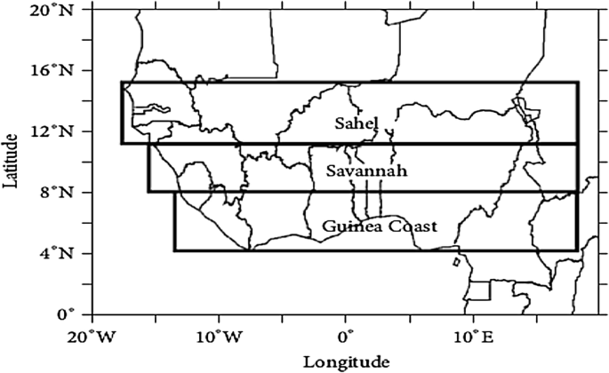

Plot the trend for the two parameters (rainfall and temperature) Guinea Coast, Savannah and Sahel: 2030 t0 2099.

Download the paper from this site and use it

<https://link.springer.com/article/10.1007/s41748-020-00161-x>